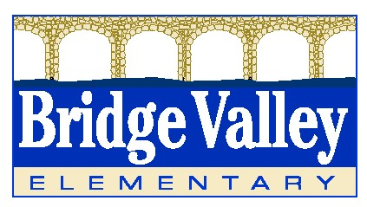 

**Welcome to Speech**

Hello Parents & Guardians!

My name is Mrs. Tara Caton and I am one of the four Speech Language Pathologists at Bridge Valley for the 2021-2022 school year. I received my Bachelors from the University of Notre Dame and my Masters from LaSalle University. I hold my Certificate of Clinical Competency from the American Speech Language and Hearing Association and am a licensed Speech Language Pathologist in Pennsylvania.

I have been working at Central Bucks for six years (this is the start of my seventh) and I could not love my job more than I already do! I grew up in Bucks County and am the youngest of four children. I have been married for a little over four years and live in Newtown with my husband, two children (Nicholas (3) and Kiera (1)), and our chocolate lab, Gus. I spent my summer enjoying the pool and beach with my family and close friends.

**If you have any questions, comments, or concerns, please feel free to contact me:**

* **Email: tcaton@cbsd.org**
* **Telephone: (267) 893-3737**

I look forward to working with you and your child by helping to reach his/her speech-language goals. Wishing you a fantastic school year!

Thank you,

Tara Caton, MS, CCC-SLP

Speech Language Pathologist